BRAINWARE UNIVERSITY
SCIENTIFIC CALCULATOR AND HOSPITAL APPOINTMENT SYSTEM

1. Basic Information
Programs Covered: | Program 1: Scientific Calculator  Program 2: Hospital Appointment System
Name(s) of Student(s): | Soumyadwip Das (BWU/BTS/25/169)  Ankita Paul (BWU/BTS/25/180)  Sonia Naskar (BWU/BTS/25/195)  Joyeta Mondal (BWU/BTS/25/214)  Sayantan Bharati (BWU/BTS/25/503)
Programme & Semester: | B.Tech CSE & 3rd Semester
Course Name & Code: | Python Programming Lab (BES09013)
Name of the Guide/Supervisor: | MR. PRANAB GHARAI & MR. INDRANIL DAS
Project Date | 11/09/2026



2. Introduction and Background
This project includes two modular Python applications: a Scientific Calculator for arithmetic and scientific functions, and a Hospital Appointment System for managing doctors, patients, and appointments. Both are menu-driven, use main.py, and store data in memory.

3. Objectives of the Project
Program 1 - Scientific Calculator
- Provide a menu of 13 operations: 7 two-number operations (add, subtract, multiply, divide, floor division, power, mod) and 6 one-number operations (sin, cos, tan, log, ln, sqrt)
- Perform trigonometric calculations in degrees and support logarithms with an optional base.
- Handle invalid inputs with clear error messages.
- Keep core math logic separate from input/output handling
Program 2 - Hospital Appointment System
- Register doctors (ID, name, specialty) and patients (ID, name, age, condition)
- View the lists of registered doctors, patients and appointments
- Book appointments only for existing patients and doctors, with unique auto-generated IDs.
- Separate models, in-memory storage and input/output into their own modules

4. Problem Statement / Driving Question
Program 1: How can a calculator separate reusable math logic from the menu while handling invalid inputs safely?
Program 2: How can a terminal system manage doctors, patients, and appointments while ensuring valid bookings?

5. Methodology
Program 1 - Scientific Calculator
- Split into 3 modules for math logic, input/output, and menu control.
- Created separate functions for each operation with safe error handling.
- Converted angles with math.radians so sin, cos and tan accept degrees
- Validated user input with try/except.
Program 2 - Hospital Appointment System
- Created Doctor, Patient, and Appointment classes with display methods.
- Centralised in-memory data storage with reusable helper functions.
- Added input validation and a shared Add/View/Back menu.
- Auto-generated IDs and verified Patient and Doctor IDs before booking.

6. Expected Outcomes / Deliverables
- Menu-driven Scientific Calculator with 13 operations and Exit option.
- Accurate results with clear error handling.
- Hospital Appointment System with Doctors, Patients, and Appointments menus.
- Valid appointments only for existing patients and doctors, using clean modular structures (3 and 6 modules).

7. Project File Structure
Program 1 - Scientific Calculator (3 modules)
.
├── main.py
└── calculator/
├── __init__.py
├── scientific_calculator.py
└── io.py

File | Responsibility
calculator/__init__.py | Package initialiser; re-exports everything from scientific_calculator and io
calculator/scientific_calculator.py | Core math logic: 7 two-number operations and 6 one-number operations
calculator/io.py | Input/output helpers: get2(), get1() and show()
main.py | Menu-driven entry point containing the MENU dictionary and main loop

Run with: python main.py
Program 2 - Hospital Appointment System (6 modules)
.
├── main.py
└── hospital/
├── __init__.py
├── doctor.py
├── patient.py
├── appointment.py
├── data.py
└── io.py

File | Responsibility
hospital/__init__.py | Package initialiser; exports Doctor, Patient, Appointment and the data and io modules
hospital/doctor.py | Doctor model: id, name, specialty
hospital/patient.py | Patient model: id, name, age, condition
hospital/appointment.py | Appointment model: id, patient ID, doctor ID, date, time
hospital/data.py | In-memory lists (doctors, patients, appointments) with add, all_of and find helpers
hospital/io.py | Input/output helpers: inp, int_inp, show, show_list
main.py | Menu flow, ID counters and the add_doctor, add_patient, add_appt handlers

Run with: python main.py

8. Core Logic (Important Code)
Program 1 - Scientific Calculator
calculator/scientific_calculator.py – core math functions (excerpt)
import math

def add(a, b): return a + b
def division(a, b): return "Error: /0" if b == 0 else a / b
def mod(a, b): return "Error: %0" if b == 0 else a % b

def sin(a): return math.sin(math.radians(a))
def log(a, base=10):
if a <= 0: return "Error: log(a<=0)"
if base <= 0 or base == 1: return "Error: bad base"
return math.log(a, base)
def ln(a): return "Error: ln(a<=0)" if a <= 0 else math.log(a)
def sqrt(a): return "Error: sqrt(-ve)" if a < 0 else math.sqrt(a)

calculator/io.py – input/output helpers
def get2():
return float(input("First: ")), float(input("Second: "))

def get1():
return float(input("Number: "))

def show(res, name):
print(f"\n--- {name} = {res} ---")

main.py – menu table and dispatch (excerpt)
# (menu_no: label, func, needs_2_inputs)
MENU = {
1: ("Add", c.add, 2), 2: ("Subtract", c.subtract, 2),
# ... entries 3 to 10 ...
11: ("Log", c.log, 1), 12: ("Ln", c.ln, 1), 13: ("Sqrt", c.sqrt, 1),
}

name, fn, n = MENU[ch]
try:
if n == 2:
a, b = get2()
show(fn(a, b), name)
elif ch == 11: # log with optional base
a = get1()
b = input("Base [10]: ") or 10
show(fn(a, float(b)), name)
else:
show(fn(get1()), name)
except ValueError:
print("Invalid number.")

Program 2 - Hospital Appointment System
hospital/doctor.py, patient.py, appointment.py – model classes (Doctor and Appointment shown)
class Doctor:
def __init__(self, did, name, specialty):
self.id, self.name, self.specialty = did, name, specialty
def __str__(self):
return f"[{self.id}] {self.name} ({self.specialty})"

class Appointment:
def __init__(self, aid, pid, did, date, time):
self.id, self.pid, self.did, self.date, self.time = aid, pid, did, date, time
def __str__(self):
return f"[{self.id}] P{self.pid} + D{self.did} @ {self.date} {self.time}"

hospital/data.py – in-memory storage and find helper
doctors, patients, appointments = [], [], []

def add(lst, item): lst.append(item)
def all_of(lst): return lst
def find(lst, _id): return next((x for x in lst if x.id == _id), None)

main.py – booking an appointment with ID validation
def add_appt():
global aid
p = data.find(data.patients, int_inp("Patient ID: "))
if not p: return show("Patient not found.")
d = data.find(data.doctors, int_inp("Doctor ID: "))
if not d: return show("Doctor not found.")
a = Appointment(aid, p.id, d.id, inp("Date: "), inp("Time: "))
data.add(data.appointments, a); show(f"Booked ID={aid}"); aid += 1

main.py – reusable sub-menu for Doctors / Patients / Appointments
def manage(title, add_fn, lst):
while True:
print(f"\n--- {title} ---\n1. Add 2. View 9. Back")
ch = int_inp("Choice: ")
if ch == 1: add_fn()
elif ch == 2:
print("Empty." if not lst else "\n".join(str(x) for x in lst))
elif ch == 9: break
else: show("Invalid choice.")

9. Core Logic (Important Code)
Program 1 - Scientific Calculator | Program 2 - Hospital Appointment System
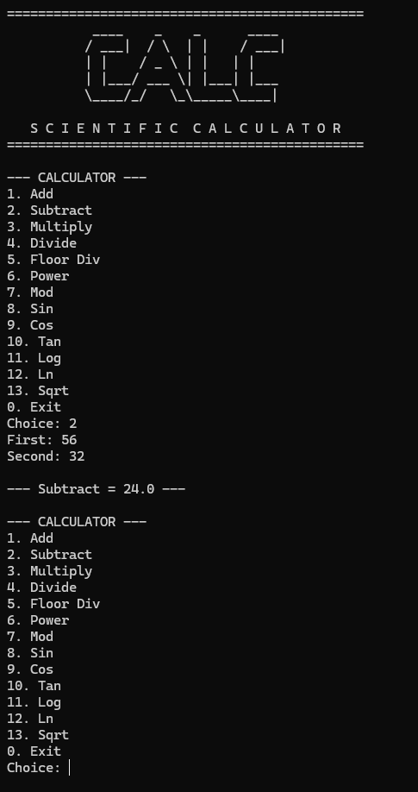 | 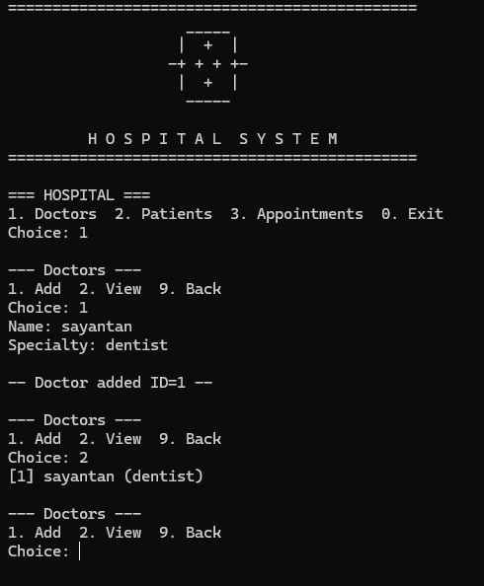

10. Tools & Technologies Used
Tool / Technology | Purpose
Python 3.x | Core language for both console systems
math module | Trigonometric, logarithmic and square-root functions in the calculator
Modules and Packages | calculator and hospital packages split into focused modules via __init__.py
Classes (OOP) | Doctor, Patient and Appointment models with __str__ display methods
Lists and Dictionaries | In-memory storage for hospital records; dictionary-driven calculator menu
Exception Handling | try/except ValueError and input re-prompting for invalid entries
String Formatting (f-strings) | Formatted menu, results and record display

11. References
- Python Official Documentation: https://docs.python.org/3/
- Python math Module Guide: https://docs.python.org/3/library/math.html
- Brainware University – Python Course Guidelines

12. Signatures
Signature of Student(s): Date of Submission:

Signature of Guide/Supervisor:

